Salesforce Interview Questions on Basics

1. What is Cloud computing?
“Cloud Computing is a new trend in IT development, deployment, Delivery module of business Products, Services that are provided over the internet that are been used by the real time User“

2.What are the Advantages of Cloud Computing?
Cloud computing has made tremendous growth in processing power, reliability of the Internet and the great increase in broadband speeds.
It makes tremendous sense to make use of the centralized server of the provider of cloud computing services as not only does it reduce the costs by a great extent by making redundant the need to buy several software licenses, it also eliminates the huge costs required by an organization to maintain and upgrade existing software.

3. What is PaaS?
PaaS means” Platform as a Service”. Here in “PaaS “the cloud service providers provides hardware, OS(operating System), Storage, Network services over the cloud. It is the way like a rent. If there is no service like Platform and there will be no Applications. Which applications are build on a Platform.

4. What is SaaS?
SaaS means Software as a Service. Through this Services all the software’s are distributes over the cloud. By using SaaS no need to install any software all software’s are readily available over the internet .

5. What is IaaS?
Full form IaaS is “Infrastructure as a Service”. Here in IaaS the cloud service providers will provides infrastructure like servers, hosting services and storage. Servers and storage’s are the basic services provide by Cloud Service Providers.

6. What are deployment modes of cloud computing?
Cloud computing services can be provided in four different deployment modes depending on size and structure of an organization. Four deployment modes of cloud computing are
- Public Cloud.
- Private Cloud.
- Community Cloud
4.Hybrid Cloud

7. What is Public Cloud?
Public cloud can be available to people across the world. In this Public Cloud the user has no control over the resources.

8. What is Private Cloud?
Private Cloud Can be accessed only with in the limited premises. In Private cloud Cloud Services Providers Cloud infrastructure to particular Organization or Business specially. This Cloud infrastructure is not provided to others.

9. What is Community Cloud?
Community cloud is a cloud infrastructure that allows systems and services to be accessible by a group of several organizations to share the information.

10. What is Hybrid Cloud?
Hybrid Cloud is the combination of number of clouds of any type but the cloud has the ability to allow data and / or applications to be moved from on cloud to another cloud. Hybrid Cloud is a combination of (Public Cloud ,Private Cloud, Community Cloud). Here API is used as an interface between public and Private Cloud.

11. Difference between Public and Private Cloud?
Public cloud can be available to people across the world. In this Public Cloud the user has no control over the resources. Where Private Cloud Can be accessed only within the limited premises. In Private cloud Cloud Services Providers Cloud infrastructure to particular Organization or Business specially. This Cloud infrastructure is not provided to others.

12. What are common factors on SaaS, PaaS, and IaaS?
SaaS, Paas and IaaS are the three types of services provided using “cloud”. Their common factor for providing services to organization and customer is the “CLOUD”depending upon the types of the service they need. Saas provides Software service on cloud where PaaS provides Platform for application development and finally IaaS provides Infrastructure.

13.What is Salesforce?
Salesforce is a company which offers one of the best customer relationship management (CRM) tool. Salesforce is among one of the best web based flexible and powerful database provider available in the market.

14.Expand CRM and briefly explain about CRM ?
Full form for CRM or Acronym for CRM is “Customer Relationship Management “. We can understand from the full form where CRM is an application used to automate Sales and marketing functions by a using a Software called CRM Software. BY using CRM Software every Company / Organization plans to increase their revenues and profits. This strategy of increasing revenue is done mainly by attracting Customers, clients, Sales etc.

15. List some CRM Software’s?
We have number of CRM softwares which are provided by top CRM companies some of them are listed below depending upon their present market.
- Salesforce CRM.
- Microsoft Dynamics CRM.
- Oracle CRM.
- SAP CRM.
- Sage CRM.
- NetSuite CRM.
- Oracle CRM on Demand.
- Oracle Sales Cloud(Fusion CRM).
- SugarCRM.
- Nimble
16.Different Salesforce Editions?
Salesforce.com provides different types of editions and features depending upon the cloud. For Sales cloud it provides four different types of editions. They are
- Group.
- Professional.
- Enterprise.
- Unlimited.
17.Number of Salesforce Editions released per year?
Salesforce Releases e updates for every year. They are
- Spring.
- Summer.
- Winter.
18. What is App in Sales force?
App means an Application. In Salesforce an Application consists a group of tabs which are designed to work as a single function. We have number of applications in Salesforce.com some of them are sales, marketing, chatter, site.com, work.com etc.
We can create new application and also customization for the existing apps in Salesforce.com. To create new app in sfdc go to Setup=>Build=>Create=>App.

19.Different types of object in Salesforce.com? And why they called so?
In Salesforce.com we have two types of objects. They are
- Standard objects.
- Custom Objects.
- Standard Objects :- Standard objects are called so because they are created and provided by Salesforce.com.
- Custom Objects :- Custom objects are those which are created by an User in salesforce.com.
Get more details on Salesforce objects:- Objects in Salesforce

20.What is an object in Salesforce?
An Objects is represented as a database table which stores organization data . Objects consists of set of fields and we store data against that field. To view data Salesforce provided TABS.
To create custom fields go to Setup=>Build=>Create=>Object.

21.What is TAB in Salesforce?
Salesforce.com provides list of tabs and are placed in Tab menu. To access data of an objects Tabs are used. Tabs in Salesforce are three types they are.
- Custom Tabs.
- Visualforce Tabs.
- Web Tabs.
22. List examples of custom field types?
Some of the custom field types are date field, Date/Time field, Currency field, Checkbox field, Number field, Text field, Pick list field, Email field, percent fields, phone field, Url field and many more.
Learn how to create custom fields :-Custom fields.

23.What are the Standard and Custom Fields in Salesforce?
Standard fields for custom objects stores the information about created by, modified by, currency, Name, owner and Division. These are the standard fields in Salesforce.com.
Custom field for custom objects store unique data or information of an organization.

24. How many custom fields can I created in an object?
In Unlimited edition we can create up to 500 fields per object. In professional edition we can create up to 100 custom fields per object.

25. What is the development life cycle we follow in salesforce?
1. Requirements Analysis
2. Design
3. Development
4. Testing
5. Deployments

26. What is sandbox?
A Salesforce Sandbox is a test environment that provides a way to copy and create metadata from your production instance – it is a separate environment where you can test with data (Salesforce records) including Accounts, Contacts, and Leads

URL to access test sandbox instances : https://test.salesforce.com
URL to access production instances : https://login.salesforce.com

It is considered best practice to configure and test in a sandbox prior to making any live changes; this ensures that any development doesn’t disrupt your live environment and isn’t rolled out before it’s been thoroughly tested.

26. What are the different types of sandbox?

There are four types of sandbox, each with its own set of characteristics that make it fit for a specific purpose. Each sandbox type has a few different variables to consider:

1. How often you can refresh a sandbox to mirror your production instance.
2. How much information you can store across data storage and file storage.
3. Whether just metadata or data is copied over.
4. Which Salesforce editions include which sandbox types.

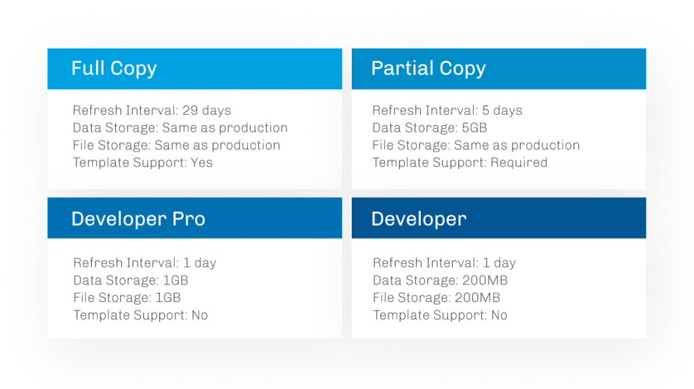

Please visit below link to know more about types of sandboxes and how to create
https://www.salesforceben.com/salesforce-sandbox/
Salesforce Interview Questions on Relationships

1. What are the different types of Relationships in SFDC?What are they?
They are four types of Relationships in Salesforce.com. They are
- Master-Detail relationship.
- Look-up Relationship.
- May-Many Relationship.
- Hierarchy Relationship (we can not use this relationship).
2. What is a “Look-up Relationship”?
- No parent is required.
- Relationship is optional.
- No impact on Security.
- Roll-Up summary fields cannot be available.
- 25 look-up relationships can be created to one Object.

3. What is “Master-Detail Relationship”?
We create Master-Detail Relationship using Junction Object in Salesforce.
- Child record must have a associated parent.
- Cascade record-level security.
- Cascade record deletion.
- Roll-up Summary fields can be established.
- Standard objects can not be a detail object.
- Standard Objects can be a Master object
- Maximum 2 Master-Detail Relationships can be created to a Object.
- Records can be re parented.

4. What is a “Self Relationship”?
Self Relationship is nothing but creating relationship between two same objects. This Self Relationship is a Look-up Relationship to the same object.

5. What is Roll-up summary?
Roll-Up Summary field in salesforce calculates values from a set of related records.

6. Define various characters of Roll-up Summary Field?
- Roll-Up Summary field can be created only in a object which is referred as a object with a master detailed relationship field.
- Roll-Up Summary field can only created for Master-detail Relationship.
- Roll-Up Summary field can not be created for Look-up Relationship.
- It Derives the data from child Object.
- We can’t change field type of a field that we reference in a roll-up summary field.
- Auto numbers are not available here.
- Roll-Up Summary fields are not available for mapping lead fields of converted fields.
7. List out the functions of Roll-up Summary field ?
- Count : It calculates the total number of related records.
- Sum : It totals the values of selected fields.
- Min : Displays lowest value.
- Max : Displays the highest value.
8. What is Many-Many Relationship in Salesforce ?
- Many-Many Relationships between two objects can be created.
- Junction Object is used to create Many-Many Relationship.
- Junction object can also be called as Join Object.
- Junction Object links each objects in Many-Many Relationship.

9. How to create Roll-up summary field on look-up relationship?
https://www.salesforcetutorial.com/how-to-create-roll-up-summary-fields-in-salesforce/

10. Can we have Roll up Summary fields in case of Parent-Child Relationships?
No.

11. Is it possible to edit Roll up summary field value in a record?
No. roll up summary fields are read only fields and they can not be edited.

12. Is it possible to create Roll up summary field on parent object ?
Yes, we can create Roll up Summary field on parent object only with master detail relation between objects.

13. How to create Many – to – Many relationship?
https://www.salesforcetutorial.com/many-to-many-relationships-in-salesforce/

14. What is Junction Object?
In salesforce, Junction Object are the part of the objects which joins one object to another. These are specially used to join many objects in Many to Many relationships.

15. What are the main things need to consider in the “Master-Detail Relationship”?
Cascade deletion of the child records is done when parent record is deleted in Master-Detail Relationship.

16. Can we convert the look up relationship to Master Detail relationship? If so How can we convert?
Yes, we can convert Look-Up relationship to Master-Details Relationship. Conversion can be done only if all the fields have valid look-Up fields values only.

17. Can we create Master Detail relationship on existing records?
Yes, It is possible to create Master-Detail Relationship on existing record. First we have to create Look-Up relationship to a record then convert it to master-Detail Relationship.

18. How to create many to many relationships between two objects?
Many to Many Relationship can be created using Junction object.
Learn how to create Many to Many Relationship in Salesforce.

19. In case of Master-Detail relationship, on Update of master record can we update the field of child record using workflow rule?
No

20. In case of Master-Detail relationship, on Update of child record can we update the field of Parent record using workflow rule?
Yes, we can update the field of parent record using workflow rule.

21. What happens to detail record when master record is deleted?
When master Record is deleted, it’s detail records are also deleted.

22. What happens to child record when a master record is deleted in Look-up Relationship?
Child records are not deleted.

23. A custom object contains some records, now my requirement is to create field in this object with master detail relationship.
No. we can not create master detail relationship first create look up relationship and associate look fields for every parent record and then convert this to Master detail relationship.

24. Can we create both master detail relationship and Look-Up Relationship at a time ?
Yes, we can create.

